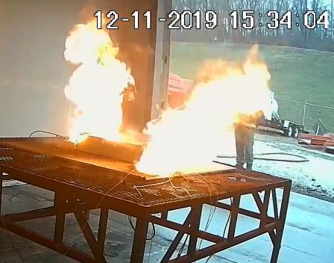

Managing UL9540a Using Intumescent Composite Thermal Barrier Design

PyroPhobic Systems, Ltd. of Barrie, Ontario, recently achieved a major product validation milestone using it’s proprietary IntuPlas fire resistant intumescent composite as part of a battery energy storage system (BESS) design to contain a runaway lithium-ion battery fire event in the BESS during UL9540A full installation testing. The test was developed and performed by Energy Safety Response Group (ESRG), a global energy safety testing and risk management firm specializing in lithium ion energy storage systems.
IntuPlas is an intumescent composite solution that is proven to contain runaway lithium-ion battery fire events. IntuPlas reacts to the heat of such a fire event by intumescing, creating an endothermic reaction that provides thermal separation between lithium ion battery cells and/or modules actively on fire, thereby thermally separating adjacent cells/modules from the cascading event. Deep seated thermal runaway events are not always easily accessible to fire fighting hose stream water. Panels of IntuPlas are integrated deep within the battery between cells and modules to provide a thermal separation, preventing propagation and fire spread. Appropriately designed BESS systems have achieved superb results based on UL 9540a testing programs.
Building and fire codes throughout the US require fire protection from the risk of lithium-ion battery fire events. NFPA 855 references UL 9540A, a test method for evaluating thermal runaway fire propagation in Battery Energy Storage Systems (BESS).

Passive IntuPlas fire containment barriers are used to achieve containment at the module and unit level. IntuPlas demonstrates the capacity to control propagation and prevent cascading thermal events, which in turn involves fewer cells resulting in less heat, and less vented hazardous gas. Based on these favourable outcomes, authorities having jurisdiction can waive the requirement to provide three feet separation between racks – a system modification that impacts the need for oversized ventilation and active fire suppression systems and affords the BESS designer greater energy density in a given footprint.

UL 9540a testing occurs at 4 different levels; beginning at the cell level, progressing to the module level, then advancing to the unit level and finally if required, then testing at the installation level. If fire propagation and deflagration hazards are not demonstrated by the test, fire code review and installation requirements are modified. Fire protection of the installation is matched to the fire performance of the BESS.

ESRG sits at the nexus of public safety and engineering, offering full lifecycle safety services to the energy storage industry from project or product conception until end of life. Among these services are support in the design of safer energy storage systems with a focus on fire and failure behavior. ESRG also performs R&D safety testing and works with NRTL partners to provide certification for energy storage systems. Following testing and certification, ESRG may provide deployment, permitting, and lifecycle safety services ensuring safety, compliance and peace of mind for your project or system long into the future.
PyroPhobic Systems manufactures a range of intumescent composite technologies and routinely collaborates with equipment manufacturers working with accredited testing facilities to obtain code compliance in accordance with specific industry testing standards and regulations. With a focus on the renewable energy sector, PyroPhobic reduces the risk that lithium-ion battery fires pose to energy storage systems, contributing to the reduction of risk to first responders, and the health and safety of green energy infrastructure.

